VBA HOMEWORK ANALYSIS

In 2014, I would not recommend purchasing Stock Ticker ATEN due to it having the greatest decrease in percent change of -68.29%. However, I would recommend Stock Ticker BBW due to it having the greatest increase in percent change of 166.23%.

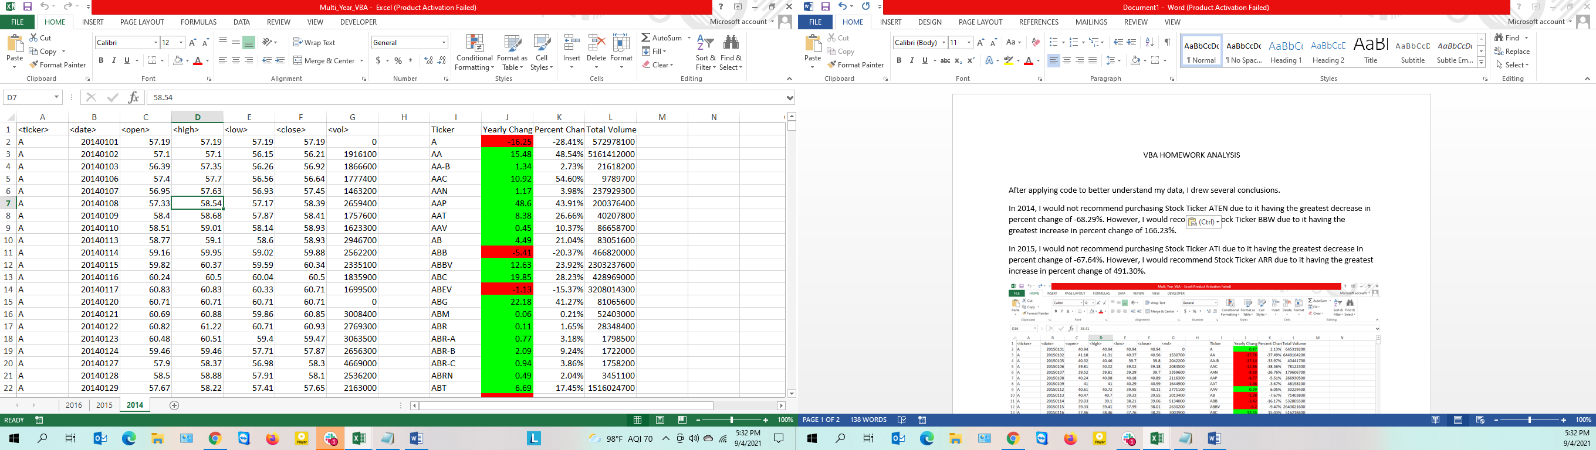

In 2015, I would not recommend purchasing Stock Ticker ATI due to it having the greatest decrease in percent change of -67.64%. However, I would recommend Stock Ticker ARR due to it having the greatest increase in percent change of 491.30%.

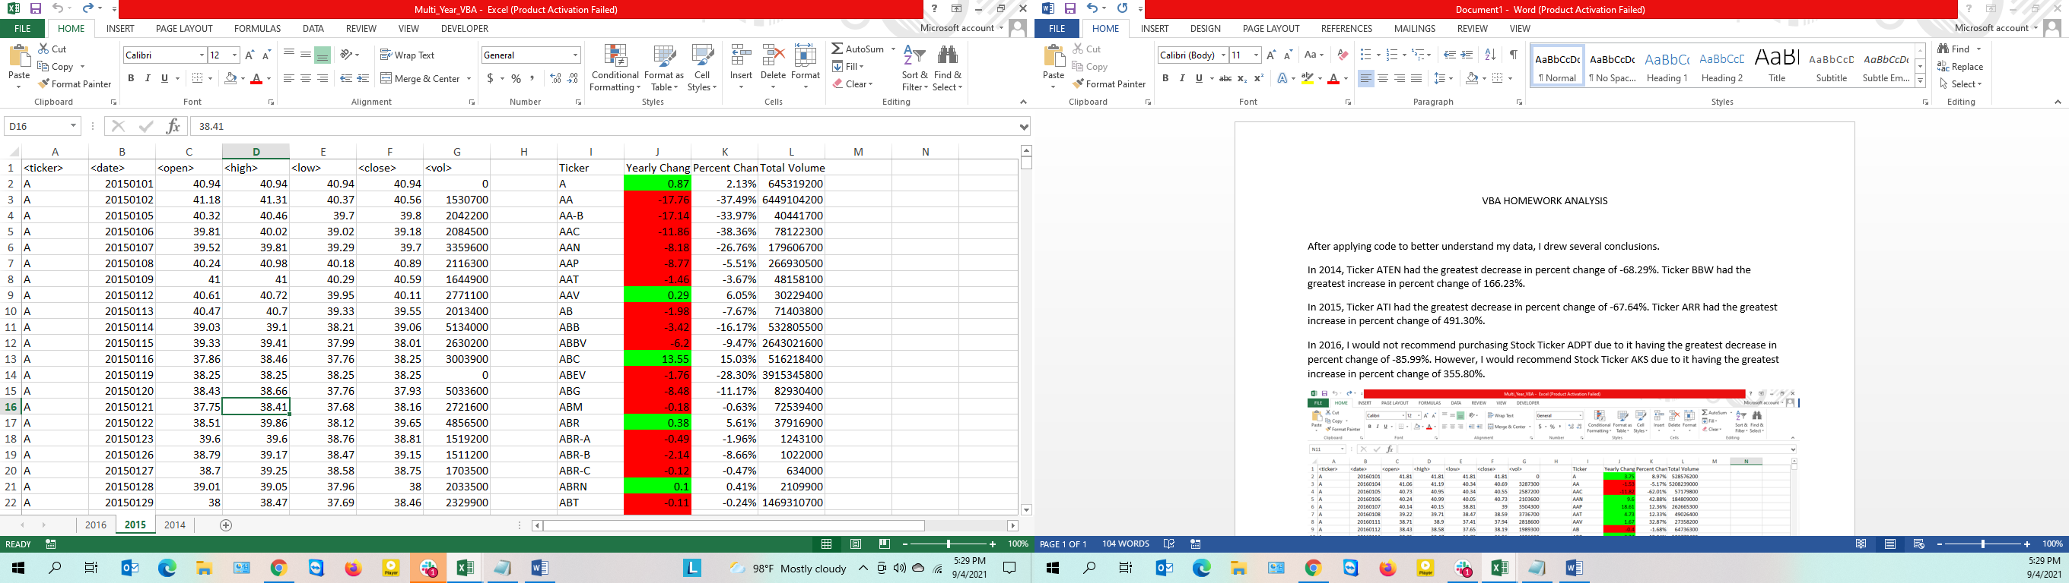

In 2016, I would not recommend purchasing Stock Ticker ADPT due to it having the greatest decrease in percent change of -85.99%. However, I would recommend Stock Ticker AKS due to it having the greatest increase in percent change of 355.80%.

